HEALTH AND

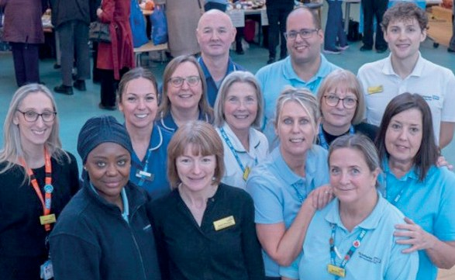

WELLBEING BOARD

**ANNUAL REPORT 2024/2025**

**A H E A L T H I E R R O T H E R H A M B Y 2 0 2 5**

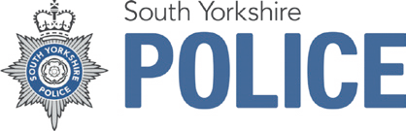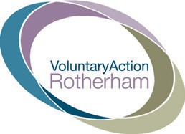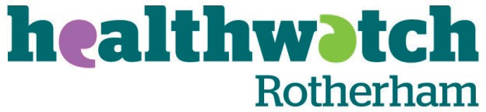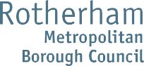



# CONTENTS PAGE

|  |  |
| --- | --- |
| **FOREWORD** | **3** |
| **ROTHERHAM’S HEALTH AND WELLBEING BOARD** | **5** |
| **GOVERNANCE** | **8** |
| **TIMELINE OF KEY ACHIEVEMENTS FROM 2020 TO 2025** | **11** |
| **BOARD DELIVERY IN 2024/25** | **16** |
| **AIM 1:**  **ALL CHILDREN GET THE BEST START IN LIFE AND GO ON TO ACHIEVE THEIR POTENTIAL** | **16** |
| **AIM 2:**  **ALL ROTHERHAM PEOPLE ENJOY THE BEST POSSIBLE MENTAL HEALTH AND WELLBEING AND HAVE A GOOD QUALITY OF LIFE** | **20** |
| **AIM 3:**  **ALL ROTHERHAM PEOPLE LIVE WELL FOR LONGER** | **23** |
| **AIM 4:**  **ALL ROTHERHAM PEOPLE LIVE IN HEALTHY, SAFE AND RESILIENT COMMUNITIES** | **26** |
| **ITEMS FROM MEETINGS JANUARY 2024 - JANUARY 2025** | **30** |
| **LOOKING AHEAD** | **37** |
| **CONCLUSION** | **38** |
| **GLOSSARY** | **39** |

**FOREWORD**

###### Rotherham’s Health and Wellbeing Board (HWBB) is a multi-agency Board of equal partners, who are working together to improve the health and wellbeing of local people. The role of the Health and Wellbeing Board is to support and encourage effective partnership working, share good practice, understand and build on local assets, as well as taking action where needed to remove barriers, identify gaps, and hold organisations to account for delivery.

I am delighted, as the Chair of the Health and Wellbeing Board, to present our seventh annual report. Health and wellbeing are important to everybody in Rotherham, enabling people to lead fulfilling lives and to be actively engaged in their community. The way individuals achieve good health will differ according to their experiences, life chances, abilities, and resources.

The Health and Wellbeing Strategy contains some ambitious aims, but by working creatively and in partnership, we feel that they are achievable and that we can make long-lasting changes that will improve the health and wellbeing of all Rotherham people.

I am proud to see that the Board is a strong and effective partnership. In the five years since we produced the strategy, partners have faced huge challenges, from the Covid-19 pandemic to the surge in living costs have continued to cause real hardship across our communities. However, the connections and relationships that have been fostered through the Board enabled us to respond quickly and decisively to these challenges, mitigating the impact for local communities.

Over the past year, Board members have not only been working to improve the health and wellbeing of the town’s population, but also been taking stock, assessing the progress we’ve made and identifying where our efforts and resources need to focus on the coming years.

A development session was held in January 2025 on proposals for a refreshed Health and Wellbeing Strategy. The strategy will be endorsed by the Board and published in June 2025, setting out our updated priorities and what we intend to deliver together.

But we should also take the time to celebrate what we have already achieved. Kooth, the online mental health and wellbeing service, has been available to all children and young people aged 11-25 in Rotherham since November 2021, as part of a range of work to support children and young people’s mental health and wellbeing.

A variety of programmes were delivered to welcome women and girls into football, focussing on under-represented groups, in preparation for the Women’s Euros being hosted in Rotherham in summer 2022.

Libraries have launched programmes, including film screenings and death cafes, to become death positive spaces, where the public can have conversations around loss, grief, end of life planning and legacy.

The Council hosted an event at Rotherham United’s New York Stadium in February 2023, which brought together partners from across South Yorkshire to discuss inequalities across a range of health outcomes.

As the cost-of-living crisis hit, the Council collaborated with local partners to develop the Warm Welcome spaces initiative, providing residents with a warm, safe place where they could receive advice and guidance and stay connected with friends and family during the winter months.

Rotherham’s leaders pledged their support to make Rotherham a Breastfeeding Friendly Borough at a launch event in August 2023, to support mums to make the right choice for themselves and their babies.

£3.4m in government funding enabled the delivery of Family Hubs and the Best Start in Life programme locally. Families can now access information, advice, and support across a range of areas, including pregnancy and birth, preparation for parenthood, health and wellbeing,

education and childcare, family support and parenting, and employment and training - all in one place.

In the last year, several events celebrating and championing equality, diversity, and inclusion or marking significant days, were promoted by the Council and local partners. This included Holocaust Memorial Day, International Women’s Day, Carers’ Rights Day, Inter-Faith Week,

The Rotherham Show, Armed Forces Day, and Mental Health Awareness Week. Rotherham town centre’s much-loved Christmas lights switch-on, which regularly sees attendances of 6,000

people, returned with a free programme of street entertainment, live music, outdoor market, and artworks to inspire the whole family.

I invite everyone to join us in celebrating our successes to date, as we continue to work together to improve the health and wellbeing of Rotherham people, reduce health inequalities and promote an integrated approach.

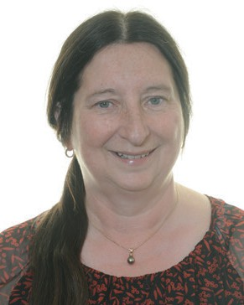

###### Councillor Joanna Baker-Rogers

Chair of the Health and Wellbeing Board

# ROTHERHAM’S HEALTH AND WELLBEING BOARD

Rotherham’s Health and Wellbeing Board brings together local leaders and decision makers to deliver our Health and Wellbeing Strategy, aiming to improve the health and wellbeing of Rotherham people, reduce health inequalities and promote the integration of services.

The Board supports and encourages effective partnership working, shares good practice, and takes action where needed to remove blockages, identify gaps, and hold organisations to account for delivery.

*Organisations represented on the board include:*

* Rotherham Metropolitan Borough Council
* NHS South Yorkshire Integrated Care Board (Rotherham Place)
* The Rotherham NHS Foundation Trust
* Rotherham, Doncaster and South Humber NHS Foundation Trust
* Voluntary Action Rotherham
* Healthwatch Rotherham
* South Yorkshire Police

The Board has several specific responsibilities, including producing Rotherham’s Joint Strategic Needs Assessment, overseeing the delivery of the Rotherham Health and Wellbeing Strategy, and producing a Pharmaceutical Needs Assessment. Further detail around the role of the Board, including how it has met the statutory duties in 2024/25, are outlined below.

#### **Joint Strategic Needs Assessment (JSNA)**

The JSNA is an assessment of the current and future health and social care needs of the local population. It brings together information from various sources and partners to create a shared evidence base, which supports service planning, decision-making, and delivery.

The JSNA is refreshed annually, and last year’s update was presented to the Board in June 2024. The JSNA includes a section on small geographies, where relevant information can be accessed at ward level, or even more local level.

#### **Rotherham context**

Rotherham is one of four metropolitan boroughs in South Yorkshire. The borough is divided into 25 wards covering a wide diversity of urban, suburban, and rural areas. Rotherham developed as a major industrial centre of coal mining and steel making, which has shaped the borough’s character. Following the decline of traditional industries, regeneration has brought new opportunities to the area, including advanced manufacturing.

Rotherham’s population has grown from 257,600 in 2011 to 265,800 in 2021 (Census 2021). Population growth has resulted from natural increase (more births than deaths), net inward migration and longer life expectancy.

General demographic and socio-economic trends have included a growing and increasingly diverse population. The population is ageing, with a high likelihood of an increase in longer-term health conditions and age-related disabilities. Inequalities persist for workless, disabled, and low paid people, who have been adversely affected by welfare reform since 2012. Health inequalities are also significant in Rotherham: in 2021-2023, the average healthy life expectancy at

birth was 56 years for males, compared with a national average of 61.5 years and 55.6 years for females, compared with a national average of 61.9 Office for Health Improvement and Disparities (OHID).

Census 2021 data indicates the borough is becoming increasingly diverse and provides an up- to-date picture of the Rotherham population. This data has been included in the report where relevant and shows how Rotherham has changed between the 2011 and 2021 censuses.

#### **Ethnicity**

The ethnic profile of the borough continues to change. Based on the 2021 census, the proportion of residents from ethnic minority communities increased from 8.1% in 2011 to 11.7% in 2021. Ethnic diversity is most evident amongst young people, as 20% of school age children were from an ethnic minority background Department for Education (DFE). The Pakistani community is the second largest ethnic group in Rotherham after white British.

Rotherham’s ethnic minority population is very concentrated in the inner areas of the town whilst the outer areas were 94% white British in 2021. 42% of ethnic minority residents live in areas that are amongst the 10% most deprived in the country and for some groups the figure is higher. This compares with the borough average of 19.5%.

#### **Age**

Rotherham has 52,228 people aged 65 years or over. This equates to 19.6% of the population, above the national average of 18.4% (2021 Census). The population aged 65 and over is projected to increase to 60,939 people by 2029, with over 10% of the population aged 75 or over (Office for National Statistics (ONS)). Rotherham has a polarised geography of deprivation and affluence. The most deprived communities are concentrated in the central area whilst

the most affluent areas are to the south, although the overall pattern is complex (source: Department for Levelling Up, Housing and Communities, Index of Multiple Deprivation 2019).

#### **Deprivation**

Rotherham is in the top 20% most deprived areas in England and 11,904 children were living in “absolute poverty” in 2022/23, according to Department for Work and Pensions figures.

#### **Sexual orientation**

2.1% of residents in Rotherham identify as lesbian, gay, or bisexual according to 2021 Census data.

#### **Gender identity**

The 2021 Census also reveals 0.6% of Rotherham residents aged over 16 identify as transgender, non-binary or have a gender identity different from their sex registered at birth, compared to 0.5% nationally.

#### **Health inequality**

Rotherham had 56,177 people, or 21.1% of the population, with a limiting long term health problem or disability in 2021, compared to 17.5% nationally. 9.8% of Rotherham residents have said that this limits their activity a lot, compared with the average of 7.5% nationally. Although there have been health improvements, health inequalities remain.

People in the most deprived parts of Rotherham experience poorer health and a higher mortality rate than residents living in the least deprived areas. Life expectancy at birth in the borough is

77.8 years for males, compared to 79.1 years nationally, and 80.9 years for females, compared to 83.1 years nationally (2021-2023). The gap between the most deprived 10% and least deprived 10% of Rotherham residents is 9.9 years for males and 9.5 years for females.

#### **Health and Wellbeing Strategy**

The Health and Wellbeing Strategy provides a high-level framework which directs the Health and Wellbeing Board’s activity. It supports the Board’s leadership role for health and wellbeing by making the most of collective resources within Rotherham. The strategy is developed based on the needs identified in the JSNA.

*The four aims of the Health and Wellbeing Strategy are:*

* **Aim 1** – All children get the best start in life and go on to achieve their potential
* **Aim 2** – All Rotherham people enjoy the best possible mental health and wellbeing and have a good quality of life
* **Aim 3** – All Rotherham people live well
* **Aim 4** – All Rotherham people live in healthy, safe, and resilient communities

*For each of the four aims, two Board members provide strategic oversight as ‘sponsors’.*

The core role of the Board sponsors is:

* To have strategic oversight and ownership of their respective aim, including:
  + Monitoring progress against aims and removing blockages.
* Providing strategic steer and identifying opportunities to develop their aim, including:
  + Action to reduce health inequalities and actions that support integration of delivery.
  + To be champions for their aim within the Board and Board activities.
  + To be champions for health and wellbeing priorities in their organisations.

# GOVERNANCE

The Health and Wellbeing Board is a statutory sub-committee of the Council and is an integral part of Rotherham’s wider strategic partnership structures that sit under the Rotherham Together Partnership. Following the changes to Integrated Care Systems in July 2022, Rotherham became one of the four constitutive Places in the South Yorkshire Integrated

Care System, with some Health and Wellbeing Board members providing representation at the South Yorkshire Integrated Care Partnership. The Rotherham Place Board continues to report into the Health and Wellbeing Board and takes strategic direction from the Health and Wellbeing Strategy.

#### **South Yorkshire Integrated Care Board** (NHS South Yorkshire)

South Yorkshire Integrated Care Board (NHS South Yorks Rotherham) is one of the four Places constituting the South Yorkshire Integrated Care Board (ICB). The ICB is directly accountable for NHS spend, delivery and outcomes within South Yorkshire. It is responsible for the commissioning of healthcare services for the population of South Yorkshire and ensuring the quality and performance of those services. Please note that the South Yorkshire Integrated Care Board is currently undergoing a reform which will impact its current role.

#### **South Yorkshire Integrated Care Partnership** (ICP)

The South Yorkshire Integrated Care Partnership (ICP) is a joint committee of the four local councils, Rotherham, Doncaster, Barnsley, and Sheffield), and the South Yorkshire ICB. The ICP facilitates joint action to improve health and care outcomes and experiences across its population, and influence the wider determinants of health, including creating healthier environments and inclusive and sustainable economies. Between autumn 2022 and March 2023, the partnership oversaw development of the South Yorkshire Integrated Care Strategy, which directs sub-regional work and is complemented by the four local Health and Wellbeing Strategies. Rotherham’s Health and Wellbeing Board nominated five representatives to sit on the ICP. *(Please note that the South Yorkshire Integrated Care Partnership is currently undergoing a reform which will impact its current role).*

#### **Rotherham Place Board**

The Rotherham Place Board is responsible for partnership business, providing the strategic and collective leadership to deliver the ambitions of the Rotherham Place. The Place Board is the forum where all partners across health and care in Rotherham come together to formulate and agree strategies for implementing the Rotherham Place Plan. It ensures alignment of relevant health and social care budgets so health, care, and support services can be bought once for a place in a joined-up way. The Chair of the Health and Wellbeing Board, along with several other Board Members, sits on the Rotherham Place Board.

Please see the diagram on the following page.

### Diagram of Rotherham Place Partnership: ‘High level’ Governance from 1st July 2022



**Rotherham**

**Rotherham Place Partner Organisation Boards**

**Together**

**P**

**artnership**

**ICB Partnership Business Business**

**Rotherham Health & Wellbeing Board**

**Rotherham ICB Place Executive Team**

*(Delivery of ICB delegated function)*

**Rotherham Place Board**

**Oversight and Management**

**of Rotherham ICB delegated functions**

**and relevant groups such as finance, quality, contracting**

**Oversight and Management**

**of Rotherham Place Transformation and Enabling Groups**

**delivering on Place priorities**

**Rotherham Executive Place Director**

**South Yorkshire Integrated Care Board**

**South Yorkshire Integrated Care Partnership**

**Rotherham Place Leadership Team** *(Strategy, planning and partnership)*

**Rotherham Place Board** (has two roles):

1. Alignment of decisions on strategic policy matters relevant to the achievement of the Place Plan.
2. Delegated authority from the ICB Board to make decisions about the use of ICB resources in Rotherham in line with its remit.

#### **Safeguarding**

Safeguarding is a priority area of collaboration for local partners, and the Health and Wellbeing Board is a signatory to the partnership safeguarding protocol. The protocol describes the roles, functions, and interrelationship between partnership Boards in relation to safeguarding and promoting the welfare of children, young people, adults, and their families. It aims to ensure that the complementary roles of the various Boards are understood so that identified needs and issues translate to effective planning and action.

Delivering on the protocol includes each Board reporting and receiving updates from one another, to ensure connectivity and appropriate oversight of issues relating to safeguarding. Chairs of the relevant Boards continue to meet to discuss shared challenges and crosscutting issues, ensuring an integrated and coordinated approach to addressing issues relating to safeguarding.

#### **Rotherham Together Partnership**

The Rotherham Together Partnership brings together statutory Boards such as the Safer Rotherham Partnership and the Health and Wellbeing Board, with other key strategic partnerships, such as the Business Growth Board, to deliver the priorities of the Rotherham Plan 2025. The Rotherham Plan was refreshed over 2022 and relaunched in January 2023.

Health and wellbeing continue to be one of the key themes in the plan, with a particular focus on embedding prevention and acting on inequalities, improving mental health, and making sure services are integrated and accessible.

The Health and Wellbeing Board contributes to achieving the vision of the Rotherham Plan, particularly in relation to improving health and wellbeing outcomes for local people in their neighbourhoods.

#### **Progress Over the Past Five Years**

With the 2020-25 Health and Wellbeing Strategy at an end, this annual report highlights the progress made over the past five years.

In implementing this strategy, we have seen the introduction of Family Hubs in Rotherham which provide a range of support and advice services to help families live well and children have the best start in life. Rotherham was awarded Level One UNICEF accreditation as a UK Baby Friendly Borough in May 2025 and is now working towards Level Two accreditation by May 2027.

The strategy transformed key care pathways and established new health services to support patients, such as developing state-of-the-art orthopaedic surgery pathways to reduce patient waiting and recovery times and the introduction of lung health checks to detect lung cancer early.

The positive impacts of our suicide prevention and loneliness work have been nationally recognised, and the Board recently approved the Prevention Concordat for Mental Health. The Board has also implemented targeted mental health support for children and young people.

Rotherham continues to be a national leader in the design and delivery of social prescribing and voluntary sector initiatives to support good health in communities and patient groups. The Rotherhive website was launched in 2020 and has facilitated access to a range of service and groups for residents and the workers who support them.

The Health and Wellbeing Board has built a coherent strategic approach to tackle the socioeconomic determinants of health. This includes Rotherham’s Sustainable Food Places Bronze award-winning food network, and promotion of physical activity through Healthwave and the voluntary sector. Several initiatives have also been developed to support staff and carers in the borough, such as workplace health checks and mental health support offers.

The following section summarises key achievements on an annual basis across the strategy’s four aims.

# TIMELINE OF KEY ACHIEVEMENTS FROM 2020 TO 2025

Tackling loneliness and social isolation during COVID-19, including reaching out to at-risk groups, raising awareness via social media, and redeveloping the MECC training.

Working with the other Boards across the Rotherham Together Partnership to deliver the safeguarding protocol, including coming together to discuss mental health as a cross- cutting issue.

An estimated 400,000 people engaged in the Rotherham Together programme, which was developed to respond and support recovery from COVID-19. The programme focussed on three key themes: Joy, Gratitude and Hope and provided innovative and Covid-secure ways to foster connectedness.

Pooling knowledge, expertise, and resources across the partnership with regards to the mental health and wellbeing of our workforce.

Establishing an unpaid carers group to ensure carers have the support they need throughout the pandemic. This group has also been closely involved in the co-production of the Carers Strategy.

Engaging with the Local Maternity System on the maternity transformation plan.

Delivery of the Suicide Prevention and Self-harm Reduction Action Plan, including promoting information around debt advice

and signposting to Rotherhive website, sharing information for people at risk of relationship breakdown, helping carers and following up missed appointments.

|  |  |
| --- | --- |
| **ALL CHILDREN GET THE BEST START IN LIFE AND GO ON TO ACHIEVE THEIR POTENTIAL** | **ALL ROTHERHAM PEOPLE ENJOY THE BEST POSSIBLE MENTAL HEALTH AND WELLBEING** |
| **ALL ROTHERHAM PEOPLE LIVE WELL FOR LONGER** | **ALL ROTHERHAM PEOPLE LIVE IN HEALTHY, SAFE AND RESILIENT COMMUNITIES** |

**2020 – 2021**

Launching the Moving Rotherham campaign to encourage local people to be more physically active. This has included activity such as the ‘Moving in Nature’ project, which is focussed on engaging local people with green spaces in their area.

The implementation of the Mental Health Trailblazer in schools ‘With Me in Mind.’ Since children returned to school in September pilot schools are reporting a significant positive impact from having Mental Health Support Teams in their settings.

|  |  |
| --- | --- |
| **ALL CHILDREN GET THE BEST START IN LIFE AND GO ON TO ACHIEVE THEIR POTENTIAL** | **ALL ROTHERHAM PEOPLE ENJOY THE BEST POSSIBLE MENTAL HEALTH AND WELLBEING** |
| **ALL ROTHERHAM PEOPLE LIVE WELL FOR LONGER** | **ALL ROTHERHAM PEOPLE LIVE IN HEALTHY, SAFE AND RESILIENT COMMUNITIES** |

Making Every Contact Count training was delivered to over 150 people and the Public Health England Better Mental Health Fund Befriender project was delivered under the Loneliness Plan.

Following engagement with Public Health colleagues, the Council’s Catering Services have achieved a Food for Life award. Further opportunities to improve food available in schools are being explored.

A variety of programmes were delivered to support local people to lead healthy lifestyles, including reducing the health burden from tobacco, obesity and drugs and alcohol, including the establishment of an outreach team to support frequent attenders to the TRFT Emergency Department with complex alcohol and mental Health needs.

Libraries have launched programmes, including film screenings and death cafes, to become death positive spaces, where the public can have conversations around loss, grief, end of life planning and legacy.

**2021 – 2022**

A variety of programmes were delivered to welcome women and girls into football, focussing on under-represented groups, in preparation for the Women’s Euros being hosted in Rotherham in summer 2022.

The Covid-19 pandemic disrupted the lives and education of children and young people and impacted on their mental health and wellbeing. The Council’s Children and Young People Services delivered targeted support for children and young people in schools. They developed a Team Around the School (TAS) model of working, working with schools and creating new resources based on their needs, with a focus on mental health wellbeing, transition and including recovery from the impact of Covid-19 on pupils’ wellbeing.

Delivered the Suicide Prevention and Self- Harm Action Plan 2020-22 and included the Be the One campaign and training to over 100 people across the partnership to

increase awareness on self-harm and suicide prevention.

Formed the ‘Our Borough That Cares Strategic Group’ to compliment COVID-19 emergency response work and support carers in the most extreme of circumstances.

These organisations remained connected and through 2021 shaped and created our Strategic Framework for 2022-2025.

|  |  |
| --- | --- |
| **ALL CHILDREN GET THE BEST START IN LIFE AND GO ON TO ACHIEVE THEIR POTENTIAL** | **ALL ROTHERHAM PEOPLE ENJOY THE BEST POSSIBLE MENTAL HEALTH AND WELLBEING** |
| **ALL ROTHERHAM PEOPLE LIVE WELL FOR LONGER** | **ALL ROTHERHAM PEOPLE LIVE IN HEALTHY, SAFE AND RESILIENT COMMUNITIES** |

Rotherham’s leaders pledged to work towards becoming a Breastfeeding Friendly borough.

Delivered a pilot supporting frequent attenders to the hospital’s emergency department through an outreach team providing a holistic offer.

A range of activities were delivered in libraries, including development of the Warm Welcome programme to support Rotherham people through the cost-of-living crisis.

During 6-12 June 2022 Carers Week, the Council organised an event, in partnership with Crossroads Care Rotherham, to

offer information, support and advice to Rotherham’s unpaid carers.

Since emerging from the pandemic, Rotherham has outperformed the national average in terms of successful completion of alcohol and non-opiate drug treatment,

demonstrating our real commitment to helping more people overcome addiction locally Rotherham has shown a steady increase.

Kooth, the online mental health and wellbeing service, made available to all children and young people aged 11-25 in Rotherham in November 2021, as part of a range of work to support children and young people’s mental health and wellbeing.

As part of this inclusive universal offer, the Council has commissioned youth work provision across the borough, working in partnership with the voluntary sector and launched the new universal youth offer

website ‘Places to Go and Things to Do’ in November 2022.

**2022 – 2023**

Mental Health Awareness and Suicide Prevention training courses were promoted across the partnership for practitioners. In 2022-2023, 7 courses were held with 95 attendees.

Rotherham was a host city in delivering a record-breaking UEFA Women’s Euros 2022.

South Yorkshire and Bassetlaw Local Authorities and NHS partners have worked together to develop the ‘Walk With Us’ toolkit for supporting children, young people and families affected or bereaved by suicide.

|  |  |
| --- | --- |
| **ALL CHILDREN GET THE BEST START IN LIFE AND GO ON TO ACHIEVE THEIR POTENTIAL** | **ALL ROTHERHAM PEOPLE ENJOY THE BEST POSSIBLE MENTAL HEALTH AND WELLBEING** |
| **ALL ROTHERHAM PEOPLE LIVE WELL FOR LONGER** | **ALL ROTHERHAM PEOPLE LIVE IN HEALTHY, SAFE AND RESILIENT COMMUNITIES** |

**2023 – 2024**

Introduced the Holiday Activity and Food Programme (Rotherham Healthy Holidays) to provide free holiday places for all children and young people from Foundation Stage 2 to Year 11 who are eligible.

Renewed strategic approach to physical activity through the Moving Rotherham partnership.

Forest View - a new post-14 specialist campus opened in September 2023, providing 50 school places.

Opened a new diagnostic centre at Badsley Moor Lane. The centre has more space, equipment and staff, and with greater capacity for certain tests, is reducing waiting times.

The annual Rotherham Show took place on 2nd- 3rd September, with approximately 88,000 visitors.

A new diagnostic centre opened at Badsley Moor Lane, providing an out-patient respiratory and sleep physiology service.

Suicide and self-harm awareness training delivered to practitioners across the partnership and members of the public. Three training sessions have been delivered to South Yorkshire Police Sargeants in 2023.

Installed Changing Places facilities in the gardens of Wentworth Woodhouse. The specialised toilet provides a purpose-built environment, designed specifically to help disabled visitors and individuals with complex care needs.

New mobile CCTV unit launched to reduce crime and anti-social behaviour.

An independent travel training (ITT) offer was created to support children with special educational needs or disabilities.

|  |  |
| --- | --- |
| **ALL CHILDREN GET THE BEST START IN LIFE AND GO ON TO ACHIEVE THEIR POTENTIAL** | **ALL ROTHERHAM PEOPLE ENJOY THE BEST POSSIBLE MENTAL HEALTH AND WELLBEING** |
| **ALL ROTHERHAM PEOPLE LIVE WELL FOR LONGER** | **ALL ROTHERHAM PEOPLE LIVE IN HEALTHY, SAFE AND RESILIENT COMMUNITIES** |

**2024 – 2025**

The Rotherham Food Network was awarded the Sustainable Food Bronze Award; a prestigious award for tackling the food challenges that are faced by communities.

RotherHive was launched in 2020 originally as a mental health resource. It has since significantly expanded and now provides a range of verified practical mental health and wellbeing information, support, and advice for adults in Rotherham.

Rotherham patients with COPD marked World COPD Day by taking part in an event designed to help them learn how to manage the condition.

New Youth Parliament members for Rotherham were elected to represent Rotherham for two years by meeting with decision-makers as well as organising events and campaigns to ensure young people’s views are heard.

Rotherham’s Reclaim the Night returned for its tenth year on 21st November 2024.

Rother Valley and Thrybergh Country Park were the latest two locations to install a Changing Place facility to support the needs of disabled visitors.

Council opens registration for its universal baby packs.

The biannual Rotherham Together Partnership event was held in September 2024 at The

Arc Cinema in Forge Island. It allowed representatives from local organisations to come together to commemorate the opening of Rotherham’s first cinema in more than 30 years and showcase the partnerships success throughout the year.

The Mental Health Community Connectors service was established in April 2024 as

a response to NHS England guidance to improve the physical health care of adults living with severe mental illness.

The Council and local partner organisations came together and developed a programme of learning events to support Safeguarding Awareness Week, which took place from

18 to 22 November 2024.

‘Giving Your Child the Best Start in Life’ guide made available for all families across Rotherham with children up to 2 years old.

# BOARD DELIVERY IN 2024/25

###### The following section highlights the Board’s progress in delivering the Health and Wellbeing Strategy during 2024/25.

**AIM 1:**

**ALL CHILDREN GET THE BEST START IN LIFE AND GO ON TO ACHIEVE THEIR POTENTIAL**

*This aim is focused on two priorities:*

* Develop our approach to give every child the best start in life.
* Support children and young people to develop well.

This section sets out key achievements including a case study on the work delivered under this aim.

*Key achievements in 2024/2025 include:*

**Rotherham Council opens registration for its universal baby packs.** The Council has invested

£360,000 in the Rotherham baby packs, which forms part of the Council’s commitment to ensuring that every child in Rotherham gets the best possible start in life. Each pack contains clothing, a toy, a book, and other useful items for the first six months, all packed in a sturdy storage box that can later be used as a memory box.

Starting from 6th January 2025, pregnant women in Rotherham whose baby were due on or after 7th April 2025 will be offered the opportunity to register to receive a baby pack. Midwives will discuss the scheme and register pregnant women for it at their 25-week appointment.

On average, there are 2,740 babies born each year who live in Rotherham, and all will be eligible to receive a pack. Continued support for children and families in Rotherham is provided through the Council’s Family Hubs Network.

**‘Giving Your Child the Best Start in Life’ guide** is now available for all families across Rotherham with children up to 2- years old. The guide developed by the Council in partnership with the Family Hubs Parent and Carers Panel, facilitated by Voluntary Action Rotherham (VAR) includes information on the following services: midwifery, health visiting, family help, parent and infant mental health, early years, volunteering, and childcare.

Delivering the Family Hubs and Best Start in Life programme is a continuation of this work which improve the support for local families. Families can access this support in-person at several one- stop shops across the borough and online through the Council website.

**The Rotherham Youth Cabinet** provides an opportunity for young people to come together, to participate in formal governance structures. The Youth Cabinet advocates on behalf of others and works in collaboration with organisations, services, strategic leaders, and frontline workers to improve outcomes for children, young people, and adults.

###### In 2024, the Youth Cabinet choose to focus their time and efforts on four priority areas:

* Anti violence
* Better personal, social, health and economic (PHSE) / religious studies (RS) education in school
* Health and wellbeing
* Climate action

In 2024, Rotherham Youth Cabinet took over the Office of the Children’s Commissioner as part of the Takeover Challenge where they explored health and wellbeing. The special

meeting provided an opportunity to question Council Officers on children and young people’s health and wellbeing and the actions being taken to support them.

**New Youth Parliament members for Rotherham.** The UK Youth Parliament (UKYP) enables young people aged 11-18 to use their energy and passion to change the world for the better.

Members of Youth Parliament (MYPs) in Rotherham are elected bi-annually and serve a two- year term of office. Nine candidates were supported to create their own manifestos. Schools and youth groups were also involved in the election process. Candidates are elected via a borough wide vote to represent the voice of young people in Rotherham on a local, regional, and national level. Over 4,000 people voted, which culminated in the results being announced at an event at Rotherham Town Hall.

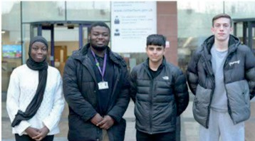

*Youth Parliament Members for Rotherham and Deputies: Giancarlo, Mabrookah, Ashaz and Jack.*

## ROTHERHAM AREA PARTNERSHIP IS AWARDED HIGHEST RATING BY OFSTED

###### Independent inspectors have praised Rotherham’s services for children and young people with special educational needs and disabilities (SEND) for their ‘genuine determination across the partnership that all children and young people with SEND are happy, successful and thrive’ and awarded them the highest rating in their inspection report.’

Following the three-week inspection in early October 2024, Ofsted and Care Quality Commission (CQC) inspectors assessed children’s services, looking at arrangements for education, health and social care services for children and young people with SEND across the borough.

There are three possible inspection outcomes in the SEND framework with Rotherham’s children’s services receiving the highest outcome of: ‘the local area partnership’s SEND arrangements typically lead to positive experiences and outcomes for children and young people with SEND. The local area partnership is taking action where improvements are needed. This means the services won’t need to be inspected again for five years.

They found ‘most children’s and young people’s needs are identified and assessed quickly and accurately’ and they ‘enjoy attending a range of mainstream schools and specialist provisions’. The report also highlighted that children and young people are valued and visible in their communities.

Praise from the inspectors comes from the collaborative way partners work together to provide support for children and young people with SEND. Partners include Rotherham Council, Rotherham’s Integrated Care Board (ICB) and Rotherham Parent Carers Forum.

Rotherham Parent Carers Forum was particularly praised for their compassionate approach in advocating for children and young people, working in partnership with services through the Four Cornerstones, Welcome and Care, Value and Include, Communication and Partnership, to influence the culture of how services for children and young people with SEND are delivered and developed in Rotherham.

## SECOND TWO-BEDROOM HOME – NEWEST ADDITION TO THE RESIDENTIAL PORTFOLIO

###### The refurbishment of the second two-bedroom children’s home in Thurcroft was completed by August 2024, following the Ofsted registration submitted in May 2024. The Council recognises that the best way to care for our children is within our own locality, as it ensures that the Council can effectively work with a multitude of health, education, and social care professionals, as well as the children’s families.

Work is taking place to transform our residential service and ensure that placements are available to meet the increasing demand on residential care homes. There continues to be a national shortage of foster placements, which enhances this demand and means that children sometimes need to be moved away from family, friends, and networks to different areas of the country. Consequently, this can impact the relationships, educational/extra-curricular achievements, health, and the emotional wellbeing of the children.

Rotherham already has a portfolio of established children’s homes, including a short breaks home for children with disabilities, four residential homes, and a supported accommodation. The borough also has two emergency and a one bedded home, which provides short term support to children experiencing breakdown in their care.

The ambition in Rotherham is to allow children in care to have an upbringing that is filled with love and happiness, which contributes to long term success and maintenance of important relationships and networks that will support children throughout their lives. Whilst the Council would like all children to live in family homes, we recognise that this is not always achievable. Therefore, it is important that the Council focusses on a model that develops smaller homes, which aid in replicating a family environment.

Having smaller children’s homes means that the Council can work to match each child well to their placement and core staff group, who are focused on the children’s individual needs and requirements. Additionally, the smaller homes model allows for more focused attention and individualised planning for children with more complex needs.

The Council recognises that the key to success in the home is the staff team. Therefore, a scrutinous recruitment process was implemented to ensure that all staff are skilled, experienced, and equipped to work with our children. The majority of

the team were in post by September 2024 and have extensive experience through working in other established homes across the service.

**AIM 2:**

**ALL ROTHERHAM PEOPLE ENJOY THE BEST POSSIBLE MENTAL HEALTH AND WELLBEING**

*This aim is focused on four priorities:*

* Promote better mental health and wellbeing for all Rotherham people.
* Take action to prevent suicide and self-harm.
* Promote positive workplace wellbeing for staff across the partnership.
* Enhance access to mental health services.

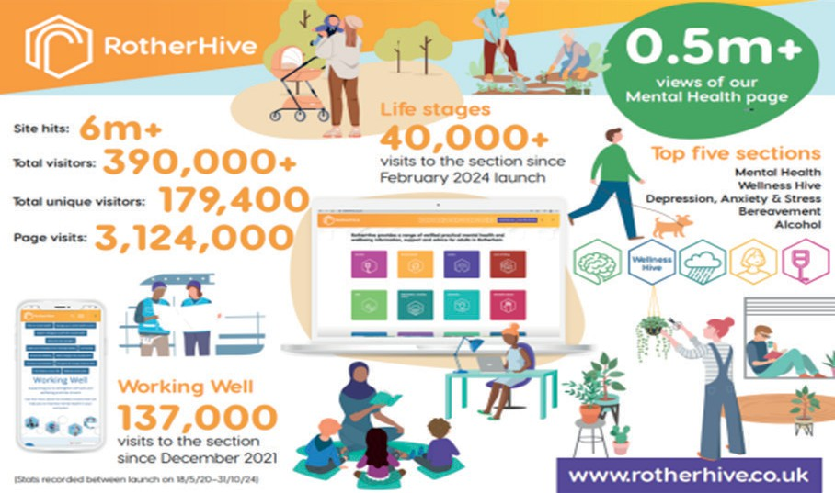

*The impact of Rotherhive since its 2020 launch*

**RotherHive was launched in 2020** originally as a mental health resource, it has since significantly expanded and now provides a range of verified practical mental health and wellbeing information, support, and advice for adults in Rotherham.

|  |  |  |  |  |
| --- | --- | --- | --- | --- |
| **Carers** | **Cost of Living** | **Debt** | **Depression Anxiety, Stress** | **Dementia** |
| **Eating Disorder** | **Eating Well** | **Gambling** | **Homelessness** | **Mental Health** |
| **Perinatal** | **Self-Harm/ Self-Neglect** | **Sleep** | **Smoking** | **Suicide Prevention** |

*Rotherhive can support residents with a range of different issues*

The Rotherhive Facebook page launched its 2024 Christmas advent calendar. In the lead up to Christmas the social media campaign covered a wide range of topics, such as debt, mental wellbeing, alcohol, self-care, gambling, sleep and coping with Christmas.

**The Mental Health Community Connectors service** was established in April 2024 as a response to NHS England guidance to improve the physical health care of adults living with severe mental illness (SMI) through improved physical health checks and supported follow-up interventions. The new service was developed with VCS delivering multi-disciplinary approach for people living with SMI and based on social prescribing model.

A key aspect was increasing uptake of SMI physical health checks in primary care, checks include height and weight measurements, blood tests, medication review, alcohol consumption and smoking status, diet and exercise review, access to screening and vaccinations.

*Patient voice workshops were held, some of the feedback highlighted:*

* A lack of prior information and advice, leading to anxiety and lack of motivation to take up appointments.
* Experiences in difficulty making contact and using appointment systems.
* On-going mental and physical illness impacting attendance and follow up.
* The need for a slow, steady approach to physical health improvements with ongoing support.

The service adapts to individual need, it is not a linear pathway but reacts to people’s needs. It aims to build trusting relationships, raise awareness of different aspects of health and wellbeing, upskill to embed healthy lifestyle behaviour into everyday life, raise feelings of wellbeing, through fostering connections with others, provide a welcoming environment and peer support and enable individuals to attend and complete their physical health checks and follow up interventions.

There have been 218 referrals into the service from primary care and after three months 100% of service users have improved their Recovery of Life (ReQol) score. ReQoL score is a measurement of quality of life for people with mental health conditions.

*Going forward the service intends to:*

* Co-produce physical health check resources.
* Map practice level approaches and challenges to physical health checks.
* Plan new collaborative approaches between Primary Care Networks (PCNs) and Rotherham voluntary sector.

**The National Academy for Social Prescribing published a new report highlighting the measurable benefits of social prescribing.** The Rotherham Social Prescribing Service is one of the services profiled in the report and mentioned in the press release:

“In Kirklees and Rotherham, frequent users of healthcare services saw GP visits and A&E attendances reduce substantially following social prescribing interventions.“

The report also suggested that social prescribing can have a positive economic impact. In Rotherham, a pre and post analysis on frequent users reported a reduction in costs up to 39% for A&E attendances.

The full report can be found at this link, Rotherham features on page 16. New report shows impact of social prescribing on health service use and costs. The latest news from NASP | NASP.

Academics at Sheffield Hallam University have been evaluating the impact of Rotherham Social Prescribing service since 2013, focusing on the long-term condition component of the service.

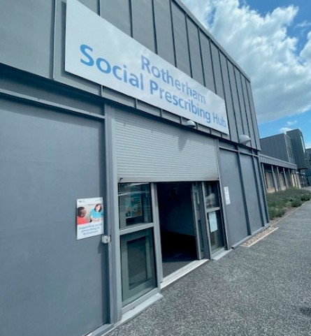

*The Rotherham Social Prescribing Hub*

The National Academy for Social Prescribing (NASP) report details the services and impact.

**Headline impact on frequent users of health services were identified as: 33%-40% reduction in non-elective inpatient spells 39%-43% reduction in A&E attendances.**

## DOMESTIC ABUSE AND SUICIDE AWARENESS TRAINING

###### A domestic homicide review was conducted in December 2024 by Rotherham Doncaster and South Humber Trust (RDaSH) Crisis Team Manager and Clinical Lead, who considered how they could enhance understanding and learning around domestic abuse and suicide in the workplace. They subsequently developed a training session around suicide and domestic abuse and invited a senior project worker from Hopian (an organisation that supports adults and children affected by domestic abuse and child sexual exploitation) to join this session to provide an overview of domestic abuse services in Rotherham. The session was attended by 18 people from across different teams.

Following the initial session, Hopian requested delivery of the same session - adapted to provide an overview of the Rotherham Crisis Team to improve their understanding. There was a real sense that Hopian were confident in contacting the Rotherham Crisis Team if they have concerns for the people who access their service and understand how working in a collaborative way providing wrap around support to individuals in crisis can enhance care. Staff mentioned that they felt reassured following speaking to members of the team.

Suicide and domestic abuse are not easy matters to talk about, many of the people who experience this adversity are equally vulnerable to health inequalities and find it difficult to access or receive the support they need. RDaSH remain hopeful that through ongoing collaborative pieces of work, with voluntary community sector

partners they will continue to improve the care for those who require it in Rotherham.

**AIM 3:**

**ALL ROTHERHAM PEOPLE LIVE WELL FOR LONGER**

*This aim is focused on two priorities:*

* Ensure support is in place for carers.
* Support local people to lead healthy lifestyles, including reducing the health burden from tobacco, obesity and drugs and alcohol.

*Key achievements in 2024/2025 include:*

**Rother Valley and Thrybergh Country Park are the latest two locations to install a Changing Place facility to support the needs of disabled visitors.** These are the eighth and ninth facilities to be installed in the borough after the Council was awarded £490,000 in

government funding. These purpose-built facilities are designed to support the needs of disabled visitors and individuals with complex care requirements including people living with learning disabilities, motor neurone disease, multiple sclerosis, cerebral palsy, and other conditions.

Changing Places facilities have also been installed at Grimm & Co., Gulliver’s, Magna Science Adventure Park, Rotherham United’s New York Stadium, Wentworth Woodhouse, and Clifton Park Museum and Town Hall.

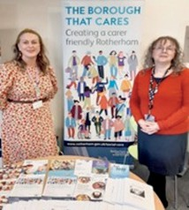**Ensuring support is in place for carers.** The Council worked in collaboration with partners to spotlight the unwavering

commitment and tireless efforts of unpaid carers. To ensure carers are aware of their rights and feel supported, a series of impactful events, ranging from open days to informative stalls were held to commemorate Carers Week, 10 to 16 June 2024. The events not only recognised the invaluable contributions that carers’ make to society, but also empowered residents with essential knowledge

about their rights and support available to them.

*Careers Week 2024*

###### Rotherham patients with COPD marked World COPD Day by taking part in an event designed to help them learn how to manage the condition.

The event, held at BreathingSpace, included patients, relatives, friends, carers, and colleagues learning more about managing chronic respiratory conditions. Advice given at the event included how to use an inhaler correctly, stop smoking support, information on clean air and demonstrations of two of the best exercises for COPD; and tai-chi (funded by Rotherham Hospital

and Community Charity).

*World COPD Day 2024*

With 2.86% of Rotherham residents having a COPD diagnosis, BreathingSpace, the hub for respiratory treatment in Rotherham, organised the event to raise awareness about COPD and how to stay healthy if diagnosed with it.

## ADULT SOCIAL CARE CO-PRODUCTION BOARD

**A new engagement forum has been established where residents can codesign adult social care services to ensure their experiences shape the future delivery of services.** The inaugural meeting of the Adult Social Care Co-Production Board was held in April 2024. Attendees included people who had expressed an interest in helping to shape the future of adult social care services during recent events. The Board collectively agreed to brand themselves as Rotherham Adult Social Care Always Listening (RASCAL) and elected a chair and deputy chair at the first meeting. RASCAL meet on the first Wednesday of every month at Rotherham Town Hall.

The purpose of the RASCAL Board is to:

* Ensure the voices of communities are placed at the centre of decision making and governance.
* Start engagement early when developing plans and provide feedback to communities on how their engagement has influenced activities and decisions.
* Understand the community’s needs, experiences, and aspirations for health and care. Using engagement to determine whether change is having the desired effect.

The Board currently comprises of 12 members, with each representative having lived experience of adult social care either themselves or as a parent, carer, or community member. The Board is diverse with representatives covering a wide range of protected characteristics.

The Council’s Adult Social Care (ASC) Service facilitates and supports representatives to attend the Board wherever possible. For example, a British Sign Language (BSL) interpreter was organised to ensure that effective communication can occur within the meetings. Representatives from the Board also collaborate with colleagues within the Council’s ASC Service to develop a forward plan of topics for discussion. Feedback from the meetings is captured to influence and shape service delivery.

Within the Board there are subgroup meetings that focus on specific topics, for example in October 2024, a discussion was held on the ASC website to ensure the content is informative and accessible to everyone. Currently, a newsletter and

webpages are being developed as a way of demonstrating the fantastic work that is being delivered by the Board.

Mohammed Riaz, Chair of RASCAL, said, “I believe in equality, fairness, and independence. People with health conditions and disabilities deserve a voice in every decision that shapes their lives because no one knows their needs and strengths better than them.

Together we can create a difference and create a much better Rotherham that embraces inclusion and understanding.

We can do so little individually but together we can do so much.”

Sam Taylor, Deputy Chair of RASCAL, said “Being a part of the RASCAL Board is such an important opportunity to advocate for improvement and change to ASC for the people of Rotherham.

The idea and purpose of the Board is to bring together members of the public to work alongside and co-produce work with ASC Officers. I believe the RASCAL Board is the key to providing high-quality services, as you have the voice of people who are going to be accessing services provided feeding back and highlighting the strengths and weakness to the Council, who can then facilitate any changes that are needed.

Being a part of RASCAL, you have the opportunity to bring issues, experience, feedback, ideas which we discuss and work through. You are a valued voice as well as giving a realistic opinion on issues or projects that the Council bring to the meetings as well.”

## ROTHERHAM FOOD NETWORK WINS A BRONZE SUSTAINABLE FOOD AWARD

The Rotherham Food Network has won a prestigious award for tackling the food challenges that are faced by communities and making local, healthy, and sustainable food available to all residents across the borough.

The Sustainable Food Place award recognises the holistic approach taken towards food and honours the positive changes made towards food issues ranging from healthy food for all to reducing food waste.

Rotherham Food Network was formed in 2022 and is a partnership made up of 26 organisations including Rotherham Council, Voluntary Action Rotherham, Rotherfed, and many more.

Achieving the bronze award recognises the steps that Rotherham has taken to raise awareness of food challenges, promote and produce locally sourced produce, tackle food poverty, and more. As well as celebrating the success of the network and its members who are actively making positive changes to Rotherham’s food sector, system, and to the way food is viewed as a society.

Rotherham Food Network is at the very beginning of their journey and welcome others to join to help improve the food system. Find out more about the Rotherham Food Network and how you can get involved [**here**](https://www.sustainablefoodplaces.org/).

**AIM 4:**

**ALL ROTHERHAM PEOPLE LIVE IN HEALTHY, SAFE AND RESILIENT COMMUNITIES**

*This aim is focused on four priorities:*

* Deliver a loneliness plan for Rotherham.
* Promote health and wellbeing through arts and cultural initiatives.
* Ensure Rotherham people are kept safe from harm.
* Develop a borough that supports a healthy lifestyle.

*Key achievements in 2024/2025 include:*

**Championing events supporting equality and inclusion.** Throughout 2024, the Council and local partner organisations have actively informed and involved local residents, including underrepresented groups, in opportunities for participation.

On 11th May 2024, the Council proudly partnered with Flux Rotherham and Children’s Capital of Culture to host the third Women of the World (WOW) Festival Rotherham. The

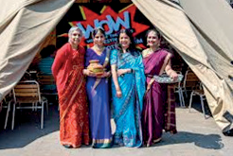

*Women of the World Festival Rotherham*

festival created a space where women, girls and non- binary people come together to discuss a range of topics, challenging societal norms and ideas that create barriers for women to succeed.

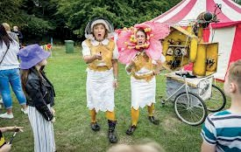Taking place on the weekend of 7th-8th September 2024, the annual **Rotherham Show** how saw over 45,000 people enjoy an eclectic mix of live music, dance, comedy, outdoor theatre and creative workshops.

Throughout the weekend the show celebrated the spirit of the borough and gave people the chance to enjoy an amazing

free festival of culture, entertainment, and family fun.

**Rotherham’s Reclaim the Night** returned for its tenth year on 21st November 2024. Residents were invited to attend a powerful evening of activities, workshops, and an annual walk-through Rotherham Town Centre to celebrate the past, present, and future of women’s empowerment.

Rotherham marked **Holocaust Memorial Day** by holding an event on 27th January 2025. The event brought together faith leaders, dignitaries, Councillors, schools, and

*Rotherham Show*

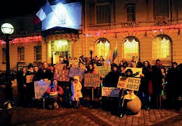

*Reclaim the Night*

local residents to remember and pay tribute all those who lost their lives to genocides around the world. This year’s theme was ‘For a Better Future’ – reflecting on how we can all help to create a better future, challenge prejudice, and speak up against Holocaust and genocide denial and distortion.

**The Council’s community tension monitoring process** enables the Council to track and monitor local issues, alongside any national or international events, which may threaten cohesion. This allows the Council to agree and implement actions to manage tensions, on the basis that early intervention can make a real difference in preventing incidents of public disorder and in keeping communities safe.

South Yorkshire Police produce a weekly assessment of community tensions which is shared with the Council’s Community Safety Team. The assessment is then shared with an internal network of key managers of front-line services to facilitate and encourage information gathering at a community level.

Information is available via a range of sources, including front-line staff in partner organisations, Councillors, schools, and voluntary, community and faith sector contacts. Information is used to assess the following measures:

* Experienced problems – based on what people in communities ‘feel.’
* Evidenced problems – actual evidence of what is happening such as reported crimes or incidents.
* Potential problems – where it is anticipated that there might be problems because of local, national or international events.

Where potential tensions are identified, appropriate routes are identified to address the issues. This may range from community engagement activities to listen to community concerns and/ or provide reassurance, liaison with Neighbourhood Policing Teams to monitor for escalation of issues, right through to more formal emergency planning structures where gold, silver and bronze command structures are convened.

The Council and local partner organisations came together and developed a programme of learning events to support **Safeguarding Awareness Week**, which took place from 18th- 22nd November 2024.

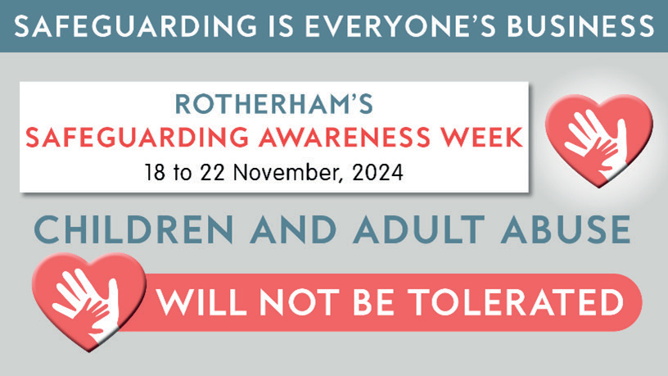Safeguarding Awareness Week is nationally recognised and has been marked in Rotherham for the past sixth years. The themes of last year’s event were ‘Neglect and Working in Partnership.’ The themes encouraged participants to consider how they can work together to establish safer cultures within workplaces and communities.

These sessions covered a range of topics, including suicide prevention, domestic abuse

*Advertising for Rotherham Safeguarding Awareness Week*

services, professional curiosity, alongside the launch of the Children’s Neglect Strategy. Aimed at frontline workers and volunteers from adult and children’s services, motivational speakers facilitated the sessions to stimulate discussion and help share best practice.

## LEADING ORGANISATIONS WORKING TOGETHER TO DELIVER IMPROVEMENTS FOR ROTHERHAM PEOPLE AND PLACES

The Rotherham Together Partnership was first established in 2017 and seeks to bring together local organisations, including the Council, NHS, Rotherham College, and South Yorkshire Police, alongside representatives of the private and voluntary sectors.

The aim of the partnership is to improve the quality of life for everyone in Rotherham by working together to deliver innovative projects.

Partners are driving action across several key themes set out in the Council Plan 2025 to create safe, healthy, and vibrant communities, underpinned by good quality housing, jobs and local infrastructure.

The biannual Rotherham Together Partnership event was held in September 2024 at The Arc Cinema in Forge Island. It allowed representatives from local organisations to come together to commemorate the opening of Rotherham’s first cinema in more than 30 years and showcase the Rotherham Together Partnership’s success throughout the year.

The event showcased the transformational work that is taking place across the borough including:

* Updates on how regeneration activity is being delivered at pace, including the Towns and Villages Fund alongside the renovation of children’s play areas.
* How the borough is being revitalised through events and activities, including the Tour of Britian, Armed Forces Day and Christmas Lights Switch-On.
* Updates were provided by the Social Value Portal on how our local partners are being supported to identify tangible actions and specific initiatives that will help make the Rotherham Pound go even further.

Rotherham Council Leader and Chair of the Rotherham Together Partnership, Councillor Chris Read, said: “at this event we reflected on what has been achieved within the last six months, while looking forward to the exciting developments that are to come, such as Skills Street at Gulliver’s Valley Resort; an immersive and innovative career training

centre that aims to inspire and inform children, young people, and adults from across the South Yorkshire region. With over 80 people in attendance, it was a magnificent way to celebrate the opening of Forge Island”.

A video has been created showcasing some of the fantastic projects, programmes, and activities that partners are delivering to respond to the needs of individuals, families, and communities in Rotherham. From restoration works at Wentworth Woodhouse, to the flagship town centre development at Forge Island, comprising of a new cinema and hotel, to inspiring creative and cultural programme, including, [**UPLIFT**](https://fluxrotherham.org.uk/projects/skate-and-art-festival/)Skate and Art Festival, Roots Carnival, the partnership is working tirelessly to make Rotherham a place that everyone can be proud of. You can find out more about the partnership working happening across Rotherham on the Rotherham Together Partnership website

## CHILDREN’S CAPITAL OF CULTURE: COMMUNITY FESTIVALS 2024

In 2025, Rotherham will become the world’s first Children’s Capital of Culture (CCoC). A programme designed and delivered by children and young people living in the borough.

In 2024, Children’s Capital of Culture had the opportunity to work closely with existing community events and festivals, supporting their growth and development whilst also enabling them to be part of our journey into 2025.

Through funding from Arts Council England, the CCoC Team were able to work with five different community festivals:

* Eastwood Fun Festival (Rotherham East ward), in June 2024
* Harthill Carnival (Wales ward), in July 2024
* Aston Carnival (Aston and Todwick ward), in August 2024
* Ferham Festival (Rotherham West ward), in August 2024
* Reclaim The Night (Boston Castle ward), in November 2024

The CCoC Team provided up to £2,000 of support to each festival, which allowed the festival organisers to enhance their offer to the communities. The Council worked with all community festivals to more strongly embed youth voice into their delivery, helping the festival organisers find opportunities to support and showcase local children and young people’s talents.

Collectively, the CCoC Team worked with 499 school pupils and 130 children and young people attending youth provision in the build-up to these festivals. The festivals themselves reached well over 10,000 participants.

The outcome of working with these community festivals was huge, especially at Ferham Festival 2024. The festival took place on Saturday 17 August 2024 and saw over 2,000 people from the surrounding areas attend.

The CCoC Team worked with 154 school children across two local primary schools to explore the children’s interests in visual art and music. Children at Kimberworth

Community Primary School created colourful banners and posters that highlighted what their community means to them, whilst Thornhill Primary School used their musical talents to write, sing, and record a ‘Thornhill Rap’ that explained their favourite things about Rotherham.

The CCoC Engagement Team also worked with a local youth group based at Liberty Church to develop performance skills and, most importantly, confidence. Attended mostly by Roma-Slovak young people, the work this group of young people produced with dance company Rationale Arts was magical. Using traditional Roma dance moves mixed with hip-hop beats and tricks, the group created a unique way to show their pride in their culture and heritage. Group members, along with siblings, parents, aunties, and uncles, all performed on the main stage at Ferham Festival.

With Ferham and Masbrough being within the 10% most deprived areas in England, opportunities for children and young people to experience quality creative activities that build essential life skills, confidence, and community cohesion is crucial. By the end of the project, the young people were able to feel real pride in talking about their own culture and community. By working with these specific groups, Children’s Capital of Culture have allowed these children and young people to experience arts and culture, breaking down barriers that may have limited their access to the creative industries.

Children’s Capital of Culture continues to work with the Liberty Church youth group to offer rich cultural experiences to the young people who regularly attend. Building relationships with their wider families is also growing, with the hopes that multiple generations can enjoy the 2025 festival year.

# ITEMS FROM MEETINGS MARCH 2024 - JANUARY 2025

This section provides a snapshot of the ongoing work across some of the partner organisations to improve the health and wellbeing of the Rotherham population.

### January 2024

**Aim 1 – All children get the best start in life and go on to achieve their potential.**

##### Foetal Alcohol Spectrum Disorder Project

A presentation on the 2-year funded project for One Adoption South Yorkshire overseen by Regional Adoption Agency (RAA) Leadership programme for Centres of Excellence on the development of a Foetal Alcohol Spectrum Disorder (FASD) Pathway.

###### Key project deliverables:

* FASD Pathway development and implementation.
* Education Psychologist contribute towards support for adopted children with FASD in school.
* Work with the Integrated Care Board (ICB) to develop an understanding of effects of FASD and develop initial support services.
* Reduction of temporary/permanent exclusions for adopted children with FASD.
* Development of SEND support plans for adopted children with FASD.
* Work with Virtual Schools to design a single integrated offer across South Yorkshire.

*The symptoms of FASD*

* Education Psychologist to link with universities, national and international research to develop approaches for supporting children with FASD.
* Education Psychologist will work directly with adopted children affected by FASD.

###### Key challenges:

* Identifying numbers affected by FASD in South Yorkshire.
* Benchmarking to demonstrate impact.
* Identifying clinical staff as part of Assessment and Diagnosis Working Group.
* Measuring the impact of the project across the 2 years due to FASD being currently under identified.
* Ensuring development of FASD pathway was scalable beyond the One Adoption Service.

###### Next steps:

* Work with Neurodevelopmental Working Group through Integrated Care Board.
* Identify clinical lead for Assessment and Diagnosis (A&D) Working Group.
* Identify who needs to be part of Assessment and Diagnosis Working Group.
* National Institute for Health and Care Excellence (NICE) Quality Guidelines: how to implement for FASC.
* Consider funding options: 2-year funding, Adoption Support Fund, other.

### March 2024

**Item of relevance to all aims**

##### Neighbourhood working and ward priorities

Our vision - Every neighbourhood in Rotherham to be a thriving neighbourhood, where people can work together to achieve a good quality of life.’; ‘Ensuring communities are at the heart of everything we do to make people feel happy, safe and proud.’

Examples of achievements that contribute towards the delivery of the Health and Wellbeing Strategy:

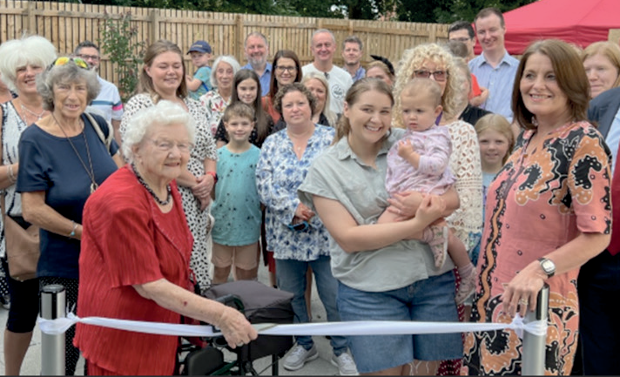

*Neighbourhood priorities are centred around creating safe, healthy, and thriving communities.*

###### **Aim 1** – All children get the best start in life and go onto to achieve their potential.

* 13 wards reference supporting children, young people and families.
* Kilnhurst and Swinton East Ward – activities in deprived areas, improving children’s play areas, school travel safety initiatives and engaging schools in local democracy.

###### **Aim 2** – All Rotherham people enjoy the best possible mental health and wellbeing and have a good quality of life.

* 9 wards reference promoting the best positive mental health.
* Hoober Ward – improve wellbeing by bringing people together whilst addressing loneliness, isolation, and mental health. Promote local activities, support existing community groups to set up a community networking partnership, continue to support bringing people together to prevent loneliness and isolation and promoting help and support available to residents in relation to the cost-of-living cost.

###### **Aim 3** – All Rotherham people live well for longer.

* 3 wards reference supporting older people.
* Maltby East Ward – support residents health and wellbeing – promoting healthy lifestyle, support existing and new community groups, thrive, and develop, supporting initiatives that improve older people’s quality of life and tackling loneliness and isolation in line with five ways of wellbeing.

###### **Aim 4** – All Rotherham people live in healthy, safe and resilient communities.

* All 25 wards include priorities that impact on the wider determinants of health.
* Anston and Woodsetts Ward – cleaner streets, lanes and open spaces and protect the environment. Work with Council services to encourage tougher enforcement on fly-tipping and littering, support and develop community initiatives to reduce litter, dog fouling and fly tipping, ensure our green spaces were properly maintained and looked after and ensure that the voice of the community was heard in any proposed planning developments.

**Aim 3 – All Rotherham people live well for longer.**

##### Annual update – Moving Rotherham Partnership

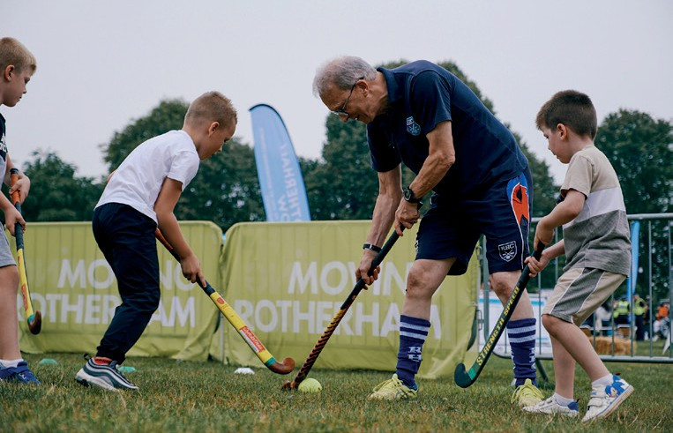The Moving Rotherham Partnership is made up of organisations working across the borough with an interest in helping local people to be more physically active.

The partnership has developed a local strategic plan, which sets out three priority areas:

* Active champions: We want to develop skills and knowledge in relation to physical activity across all

organisations and services, so that conversations with

*The wider determinants of health*

local people about being active happen as often as possible.

* Active environments: We want to help create environments than enable physical activity, whether this is outdoors in green spaces, town centres and local streets, or within schools, colleges, and workplaces.
* Active communities: We want to create opportunities for people whatever their age, background or ability and use physical activity as a way for people to connect, share experiences and contribute to a thriving borough.

*The following achievements were highlighted:*

* The Say yes prevention campaign was launched at Rotherham Show with ‘Say Yes to joining in’ with the activities.
* Training to social prescribers/link workers to increase awareness of benefits of physical activity and confidence.
* Active environment: Uplift Festival, Rotherham10K, Herringthorpe Stadium refurbishment, cycle lane infrastructure improvements, play zone facilities.
* £63,567 awarded to community groups through Sport England Together Fund.
* Women’s Euro Legacy Programme 368 hours of volunteer time contributed.

## June 2024

**Item of relevance to all aims**

##### Rotherham’s Joint Strategic Needs Assessment (JSNA)

Rotherham’s Joint Strategic Needs Assessment brings together data and intelligence to inform the local understanding of the current and future health needs of Rotherham people.

A summary of key findings, interpretation and data is available below:

**Health behaviours**

* 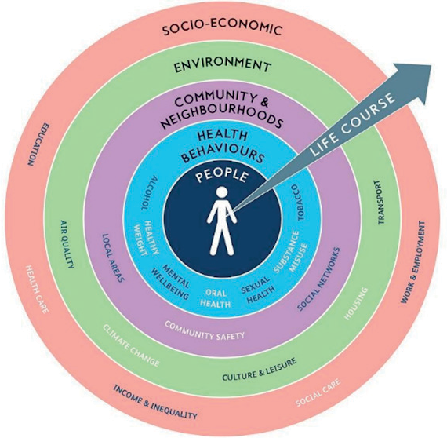The Rotherham Drug and Alcohol Service (ROADS) has been supporting more people with substance and alcohol use;

the number of new presentations to treatment for adults increased from 960 in 2022/23 to 1,070 in 2023/24; the number of new presentations to treatment for children aged under 18 increased from 45 in 2022/23 to 70 in 2023/24.

* There had been a significant increase in the percentage of physically active adults in Rotherham from 54.9% in

2018 to 64.1% in 2022/23. Despite this, health conditions

which were associated with having a lower risk in physically

*The Joint Strategic Needs Profile*

active adults (such as CHD, Stroke and Hypertension) all had significantly higher rates in Rotherham than Yorkshire and the Humber and England.

* Smoking prevalence in Rotherham in 2023 was at 14.5% of adults compared with 11.6% across England. Quit rates in Rotherham had nearly doubled from 1,580 in 2018 to 3,155 in 2022.
* The proportion of adult general practice patients who were newly diagnosed with depression in Rotherham in 2023/24 was 1.5%, the same as the England average. This has fluctuated between 2013/14 and 2023/24 but remains lower than the previous two-years.
* Around 1 in 4 (24.7%) children aged 4-5 years were categorised as overweight or obese for the2023/24 period, however, this was 2 in 5 (40.5%) for children aged 10-11 years for the same period. For adults almost 3 in 4 (73.7%) were categorised as overweight or obese in 2022/23.

## September 2024

**Aim 2 – All Rotherham people enjoy the best possible mental health and wellbeing and have a good quality of life.**

##### Rotherham prevention concordat for mental health

A report on the prevention concordat which focussed on upstream interventions and the wider determinants of health was presented to the Board. It was a whole population approach and included those at greater risk supporting joint cross-sectoral action locally, including those with lived experience and the wider community. It encouraged collaborative working to address local needs and identify local assets and was about building the capacity of the local workforce to prevent mental ill health.

A presentation was delivered that focussed on the work that had taken place during the last year:

* Mental health asset mapping – statutory and voluntary sector services.
* Prevention and Health Inequalities Plan – focusing on people with mental health conditions and improving their health and wellbeing.
* Strong Partnership Groups – Better mental health for all and suicide prevention groups (Council, South Yorkshire Integrated Care Board Rotherham Place, RDASH, Voluntary Action Rotherham, South Yorkshire Police)
* New information on RotherHive – pain management, physical activity.
* Workforce development –mental health, loneliness, sleep, and suicide prevention training.
* Rotherham Social Prescribing Service – supporting residents with long-term health conditions, including those who present with a mental health condition.

**Aim 4 – All Rotherham people live in healthy, safe, and resilient communities.**

##### Rotherham Loneliness Action Plan 2023-25

An update on the action plan which recognised that loneliness was experienced across the life course and could only be tackled by actions from all partners and the public was presented to the Board.

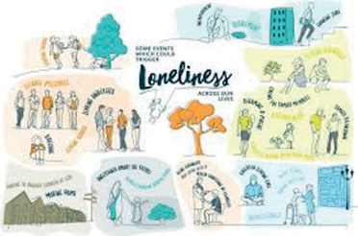The following achievements were highlighted:

* Delivering ‘The Making Every Contact Count’ e-learning programme is designed to support learners in developing an understanding of public health and the factors that impact on a

person’s health and wellbeing. 119 staff trained from January to September 2024.

* Humanitarian and Communities Group

developed an action plan to respond to cost of

*The Loneliness Action Plan on a Page.*

living related issues, including tackling loneliness and isolation through the establishment of a new Rotherham Creative Health Board.

* South Yorkshire Police Hate Crime Co-ordinator working with partners and organisations across Rotherham to raise awareness of hate crime and how to report.
* Continue to deliver the digital inclusion programme to enable residents to enjoy the benefits of getting online, including booking health appointments, and managing their health information online, apply for and access Council/Government services, and finding and applying for job vacancies online.
* Open Arms drop-in sessions – voluntary community sector partners delivering a co- ordinated response to support communities most affected by the cost-of-living crisis.

### December 2024

**Aim 4 – All Rotherham people live in healthy, safe, and resilient communities.**

##### Consultation for the Safer Rotherham Partnership Plan 2025-28

The Safer Rotherham Partnership brings together partner organisations to tackle crime and community safety threats across the borough, so that people are safe and feel safe.

Organisations represented include Council, South Yorkshire Police (SYP), South Yorkshire Integrated Care Partnership (ICP), Probation Service, South Yorkshire Fire and Rescue Service (SYFR), South Yorkshire Mayoral Combined Authority (SYMCA), Voluntary Action Rotherham (VAR), South Yorkshire Violence Reduction Unit and Victim Support.

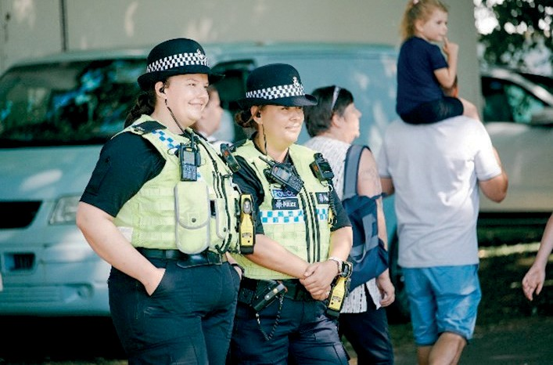The partnership is reviewing its priorities for the next 3 years. This will be informed by a comprehensive review and analysis of crime and community safety data (police and partner sources), outcomes from the Joint Strategic Needs Assessment, consultation with public and communities via online survey, events, and focus groups, including voluntary and community sector representatives, communities of interest, geographic

communities, general public.

###### Next steps:

*The safe Rotherham Plan brings together a range of organisations to keep people safe.*

* The Safer Rotherham Partnership Board to agree the priorities (December 2024-February 2025)
* Final strategy was agreed in April 2025, with a delivery plan developed in June 2025.

**Item of relevance to all aims**

##### Health and Wellbeing Strategy Refresh

An update on the work taking place to produce a refreshed Health and Wellbeing Strategy for 2025.

The Strategy Steering Group was meeting monthly to shape the 4 current workstreams ensuring that the relevant priorities and focus would be embedded in the new Strategy. These were:

* A review of prior consultation and engagement exercises and existing reports pertaining to the health, wellbeing and care needs of the Rotherham communities drawing out recommendations and identified gaps in delivery.
* A review of the evidence and opportunities for developing the strategic response to population health and wellbeing needs arising from the evidence collated in the Joint Strategic Needs Assessment.
* Stakeholder engagement. A stakeholder survey for commissioner and provider organisations across Rotherham would close in mid-December. There were also cross- agency workstream events taking place.
* A programme of citizen engagement activity.

The evidence generated was used to pull together a high-level draft of the Strategy in early January.

### January 2025

###### **Aim 3** – All Rotherham people live well for longer. The Borough that Carers Strategic Framework

The Borough That Cares Strategic Framework concludes its 3-year term in 2025.

Presentation highlighted the work undertaken over the last 3-years in the following areas of focus:

###### Focus 1 - Carers Cornerstones

* + From May 2023 the Better Care Fund has provided £100,000 for the provision of small grants of up to £5,000 to small VCS organisations, for projects to improve the health and wellbeing of carers.
  + Updated Council website carers information pages and re-designed in readiness for launch of new corporate digital platform.
  + Carers directory published and made available in PDF format on Council webpages.
  + Bi-annual carers newsletter established; four editions published.

###### Focus 2 - Creating Communities of Support

* + Robust co-production platform in place with the Borough that Cares Network and Adult Social Care Co-Production Board (RASCAL).
  + Held Carers Conversations co-production programme:
  + 12 co-production events in partnership with locality-based support groups focused on accessing advice and information, support services and improving health and wellbeing.
  + Example outcome - Unpaid Carers App – funding secured from the Accelerating Reform Fund.

###### Focus 3 - Carer Friendly Borough

* Carers Week and Carers Rights Day events held across the borough – now well-established making Carers visible within communities.
* Strong links with Voluntary Action Rotherham supporting voluntary community sector unpaid carers groups.
* Adult Care Carer Link Officers established within Adult Care and Integrations Supporting Independence Team to provide additional capacity for the service’s completion of Carers Assessments, in accordance with our Care Act duties, and information provision.

###### Next steps:

* Co-production of revised Carers Strategy 2026 – 2029
* Foundation established, so focus on:
  + NICE Guidance (NG150) supporting adult carers
  + Prevention and early intervention
  + Young Carers transition to adult carers
  + Improving equality data held
  + Completion of an equalities analysis
* Ensure Adult Care Co-Production Board (RASCAL) enables Carers to influence service design, alongside professionals and the voluntary and community sector.
* Carer involvement in LGA Peer Assessment and CQC Assurance process.

# LOOKING AHEAD

The ambition for 2025/26 is to build on the work and recommendations from the last year’s report and to deliver the following:

* Launch our refreshed Health and Wellbeing Strategy for 2025-2030 at September Health and Wellbeing Board meeting.
* Develop an action plan setting out the core activities that the Board will oversee in 2025-2026.
* Continue to work with Board sponsors to monitor delivery of our strategy.
* Continue to develop our relationships within the new South Yorkshire Integrated Care System and ensure each of our aims is aligned with the South Yorkshire Integrated Care Strategy.
* Continue to focus on reducing health inequalities between our most and least deprived communities.
* Influence other bodies and stakeholders, including those with a role in addressing the wider determinants of health to embed health equity in all policies.
* Produce an annual report each year with case studies, giving people the chance to hear about what has been achieved and the impact it has had.

# CONCLUSION

The 2024/25 Annual Report is the final one under the Health and Wellbeing Strategy for the 2022-25 period. This has required a more reflective approach to reviewing the 2024/25 period that has contributed towards developing the new Health and Wellbeing Strategy for 2025-30. Reviewing our successes and challenges has informed the ways of working, aims and priorities of the new Strategy and will further develop the impact of the Board moving forward. The Health and Wellbeing Board will continue to work towards delivering improved health outcomes for its residents and improve the wellbeing of the people of Rotherham.

# GLOSSARY

**A&E** - Accident and Emergency

**ASC** - Adult Social Care

**BAME** - Black, Asian and Minority Ethnic

**BSL** - British Sign Language

**CCoC** - Children’s Capital of Culture

**COPD** - Chronic Obstructive Pulmonary Disease

**CQC** - Care Quality Commission

**DfE** - Department for Education

**FASD** - Foetal Alcohol Spectrum Disorder

**GP** - General Practice

**HWBB** - Health and Wellbeing Board

**ICB** - Integrated Care Board

**ICP** - Integrated Care Partnership

**JSNA** - Joint Strategic Needs

Assessment

**MYPs** - Members of Youth Parlaiment

**NASP** - National Academy for Social Prescribing

**NICE** - National Institute for Health and Care Excellence

**NHS** - National Health Service

**NHSE** - National Health Service England

**OHID** - Office for Health Improvement and Disparities

**ONS** - Office for National Statistics

**PCN** - Primary Care Network

**PDF** - Portable Document Format

**PSHE** - Personal, Social, Health and Economic

**RAA** - Regional Adoption Agency

**RASCAL** - Rotherham Adult Social Care Always Listening

**RDaSH** - Rotherham Doncaster

and South Humber Trust

**ReQoL** - Recovering Quality of Life

**ROADS** - Rotherham Drug and Alcohol Services

**RS** - Religious Studies

**SEND** - Special Educational Needs and Disabilities

**SMI** - Severe Mental Illness

**SYFR** - South Yorkshire Fire and Rescue

**SYMCA** - South Yorkshire Mayoral

Combined Authority **SYP** - South Yorkshire Police **TAS** - Team Around the School

**TRFT** - The Rotherham NHS Trust

Foundation

**UEFA** - Union of European Football Associations

**UKYP** - United Kingdom Youth Parliament

**ITT** - Independent Travel Training **VAR** - Voluntary Action Rotherham **VCS** - Voluntary and Community

Sector

**WOW** - Women of the World